Game Design Document

Fill up the following document

1. Write the title of your project.

Training Shooting Game

1. What is the goal of the game?

To make the PC complete his training in shooting

1. Write a brief story of your game.

A person has a tournament coming up.He has to train for that tournament. We will help him to train by creating random objects.He will have to shoot those objects to clear the training.

1. Which are the playing characters of this game?

* Playing characters are the ones who respond to the user based on the input from the user.
* Cars, monkeys, dinos, wizards, etc., are the playing characters in the game.

|  |  |  |
| --- | --- | --- |
| Number | Character Name | What can this character do? |
| 1 | The person which is doing the training | Shoot the targets with his guns |
| 2 |  |  |
| 3 |  |  |
| 4 |  |  |
| 5 |  |  |
| 6 |  |  |
| 7 |  |  |
| 8 |  |  |

1. Which are the Non-Playing Characters of this game?

* Non-Playing characters are the ones that don't have an action or behavior when the user interacts with the game.
* Hurdles, stones, bananas, coins, etc., are non-playing characters in the game.

|  |  |  |
| --- | --- | --- |
| Number | Character Name | What can this character do? |
| 1 | Targets | They will just stand until the PC will shoot them |
| 2 |  |  |
| 3 |  |  |
| 4 |  |  |
| 5 |  |  |
| 6 |  |  |
| 7 |  |  |
| 8 |  |  |

Draw your imagination of this game. What does this game look like?

* Draw the game either on your computer or on paper.
* Add images of the game scenes to show each of the playing and non-playing characters at least once.

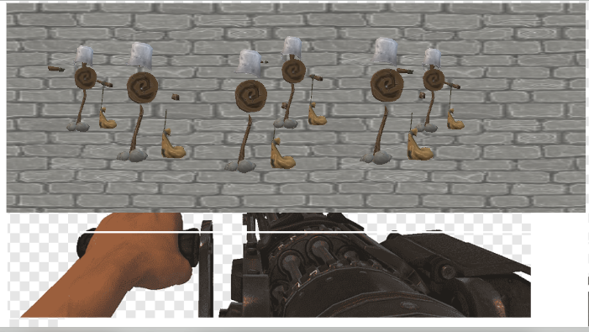

How do you plan to make your game engaging?

This game is going to be very interesting

You will have to shoot all the targets one by one

The difficulty will increase each time we hit a target